DESCRIPTION
This agent procedure is designed to address Dell driver issue. It leverages PowerShell script to remove faulty dbutil_2_3.sys driver in system and users’ temp folders.
The procedure will also update the dbutil driver if the variable DbutilRequired at the line 6 is set to 1.
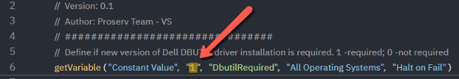

Install instructions
1. Extract the files from the attached zip file.
2. Upload the Power Shell file to the Shared Files directory of the Managed Files folder: https://helpdesk.kaseya.com/hc/en-gb/articles/360017878358.
3. Import the XML into the agent procedure module: https://helpdesk.kaseya.com/hc/en-gb/articles/229012068.
4. Execute the procedure on a target machine.

